1. Go on www.irs.gov and click on “Make a payment”

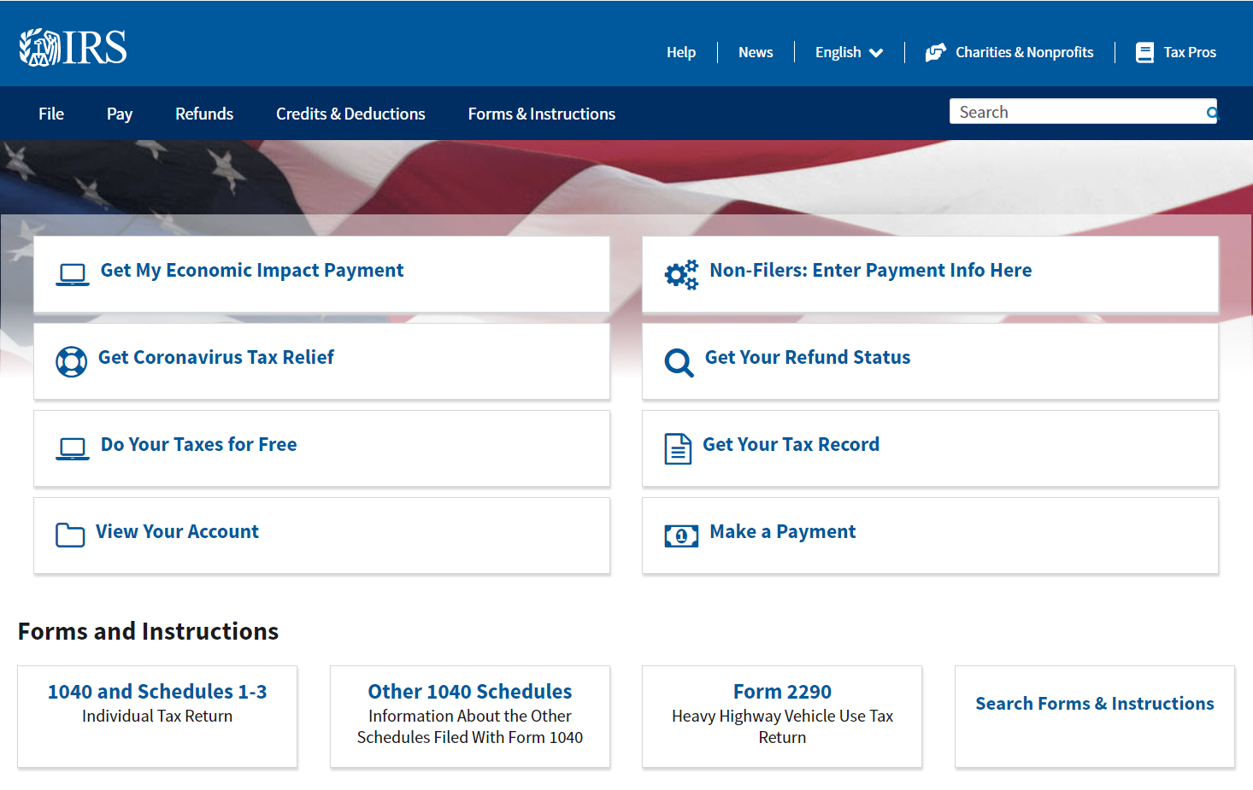

1. Choose your payment method under “Pay Your Taxes Now” – P.S: using your bank account information to make a payment will save you 2-3% transaction fee using a card.

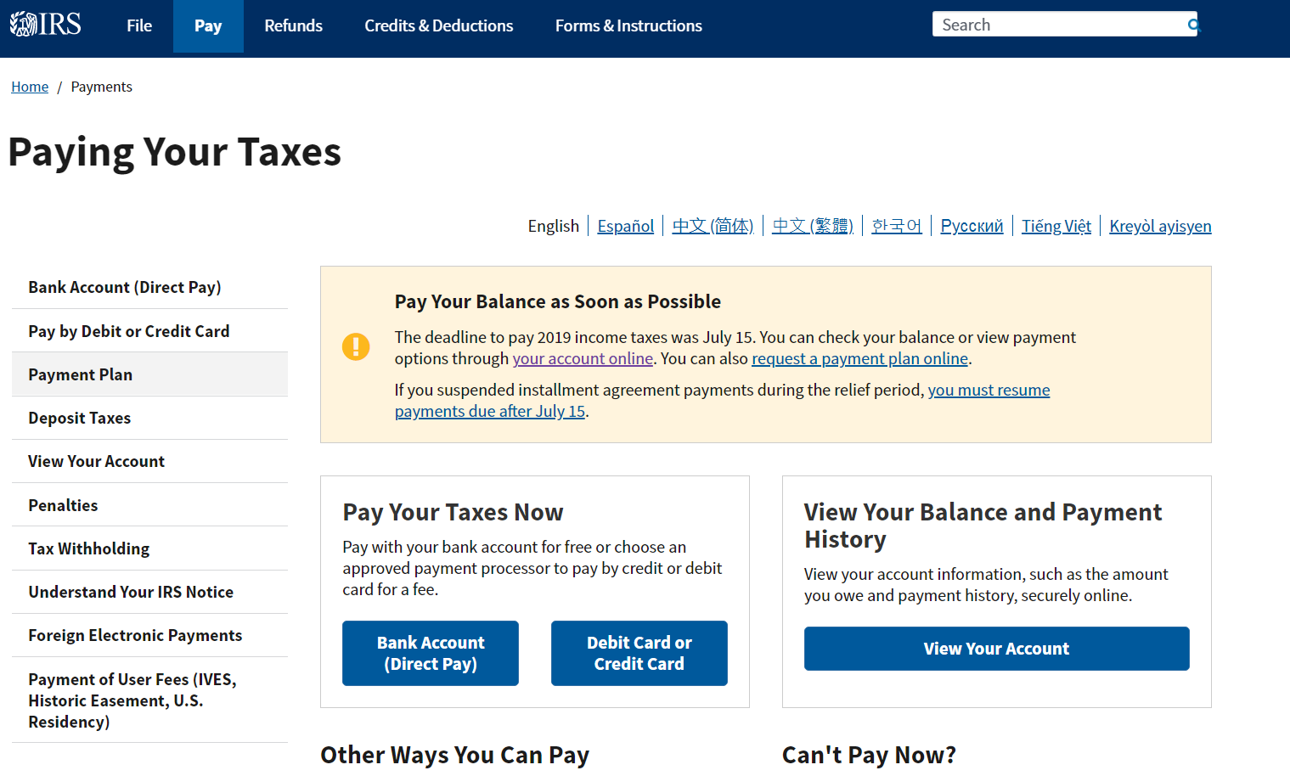

1. Click on “Make a Payment” and use the $ amount on your voucher or a customized $ amount based on the conversation you had with Alfred

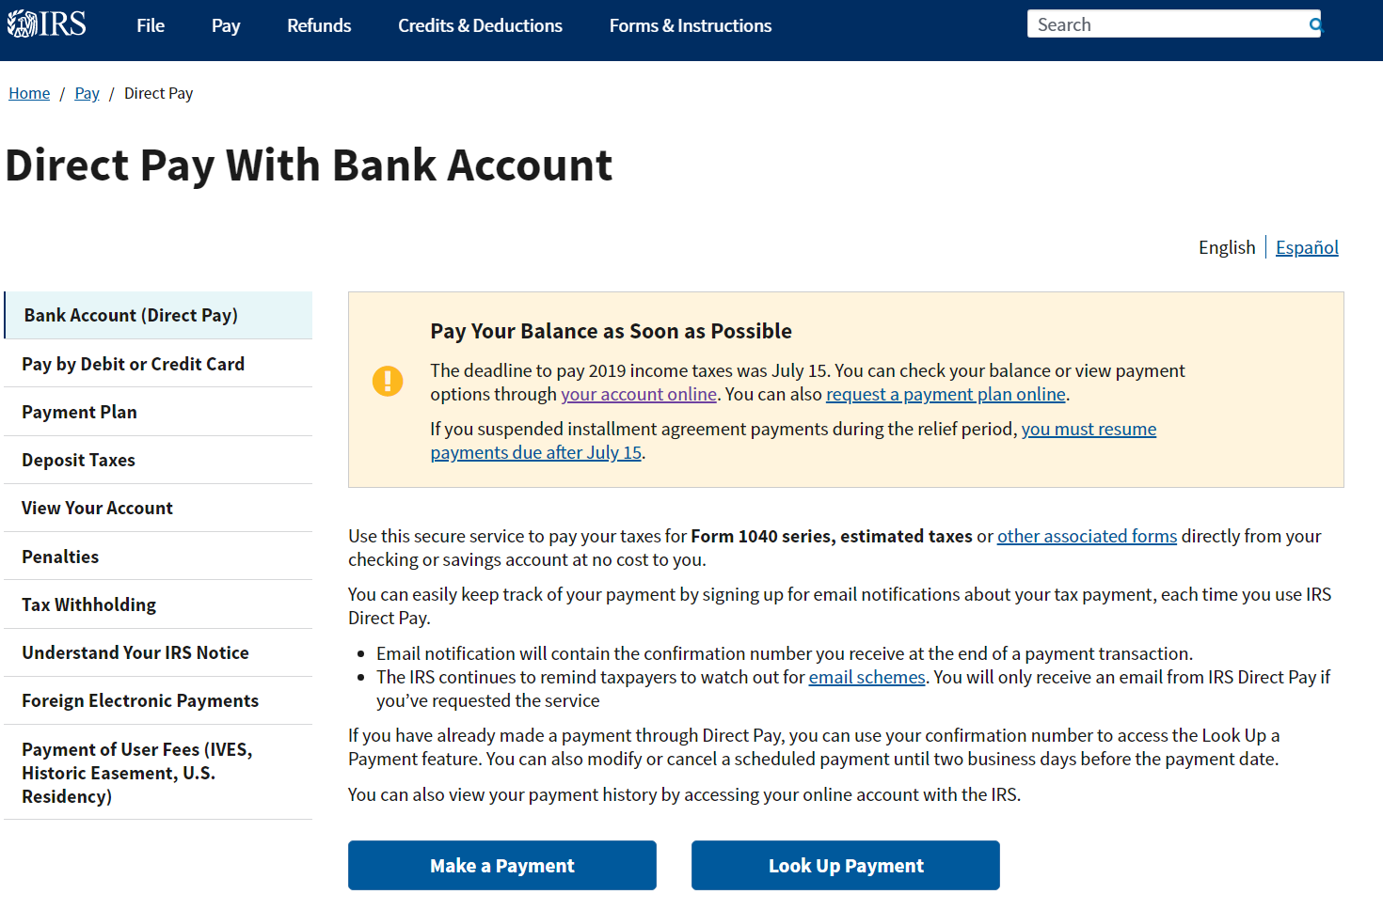

**Make sure you print out the receipt/confirmation page and keep it for your records**