1. Go on [www.ncdor.gov](http://www.ncdor.gov) click on “File & Pay” and use the drop down menu to choose “Individual Income Tax – Form NC-400V”

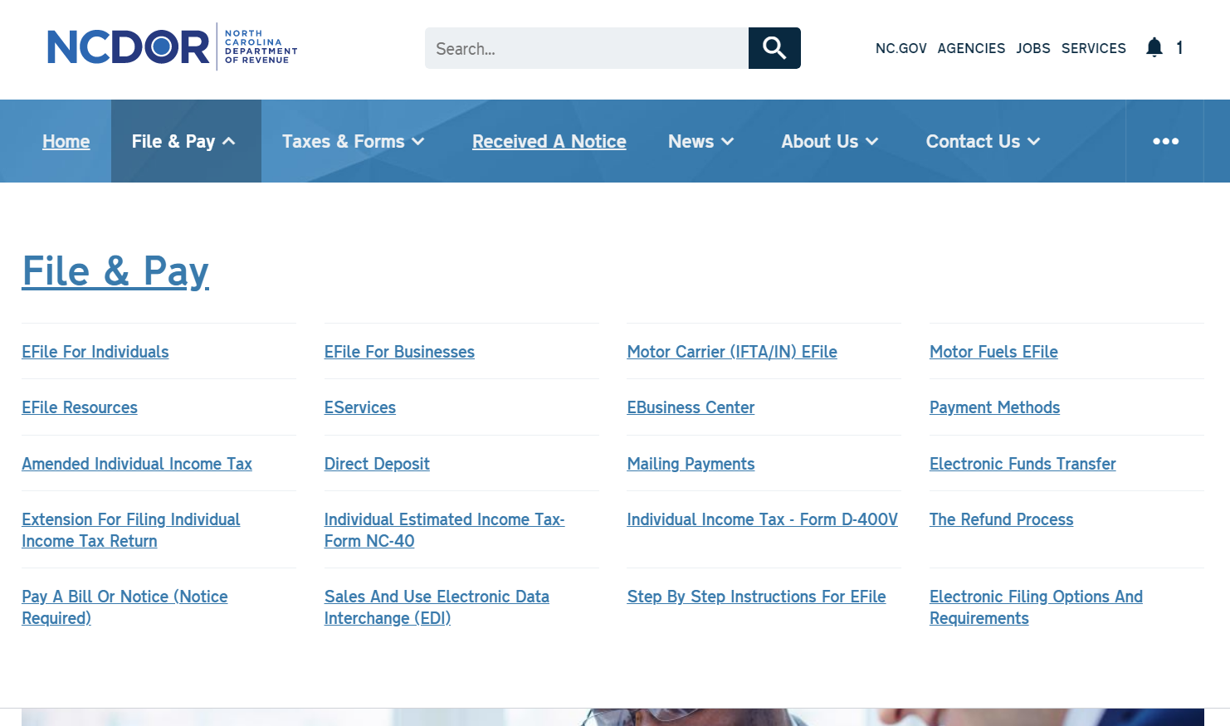

1. Click on “Pay Individual Income Tax”

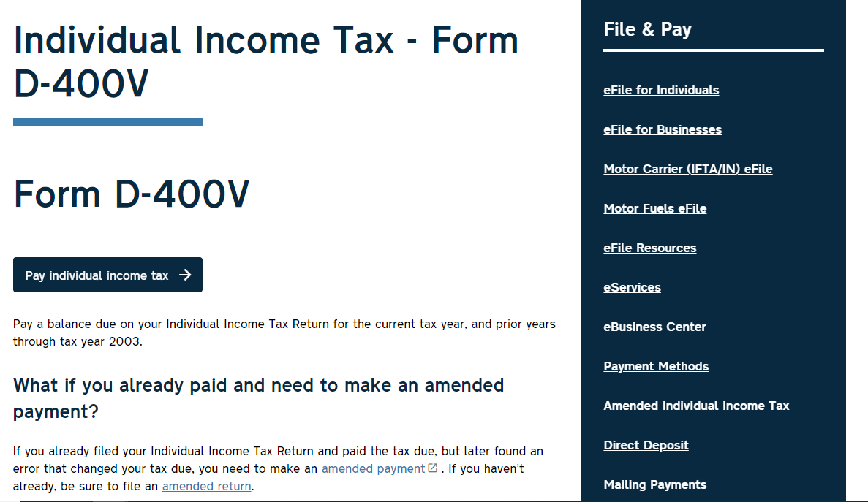

1. Fill out your personal information and choose a payment method (P.S: using your bank account information to make a payment will save you 2-3% transaction fee using a card). Use the voucher $ amount or a customized $ amount based on a conversation you had with Alfred

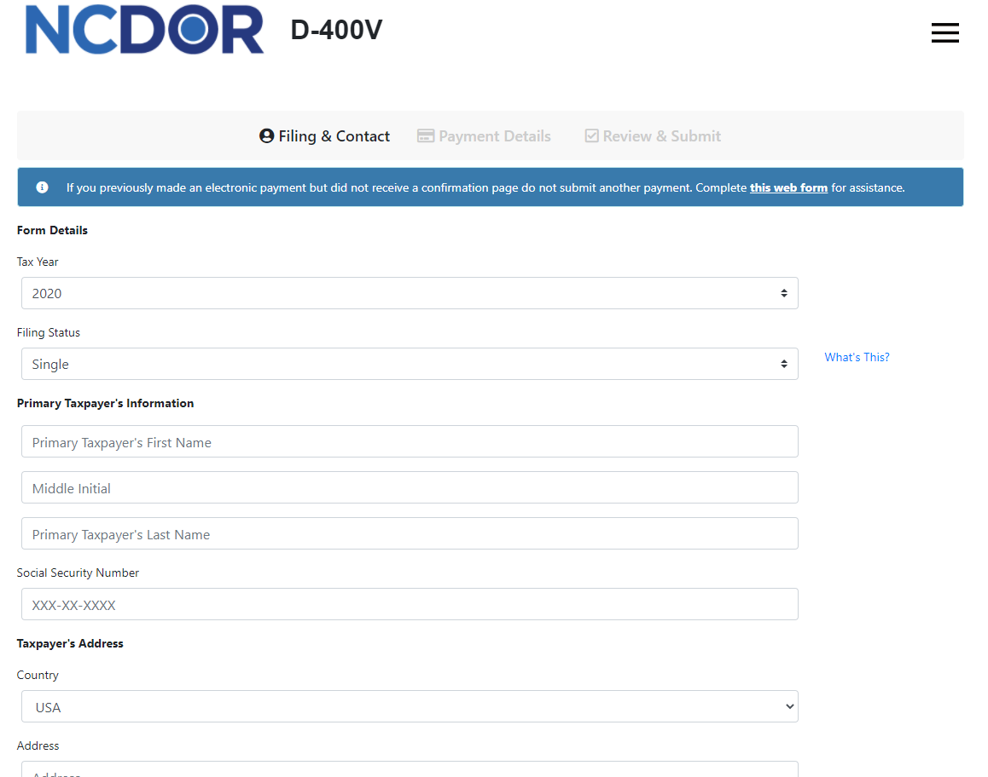

**Make sure you print out the receipt/confirmation page and keep it for your records**